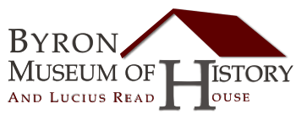

My Trip to the Byron Museum of History

Name:________________________ Grade:______________ Date:_________________

My Favorite part of the visit was: ___________________________________________________

________________________________________________________________________________

I was surprised to find out that: _____________________________________________________

________________________________________________________________________________

I would like to learn more about: ____________________________________________________

________________________________________________________________________________

Draw a picture below about your favorite part of the museum.

