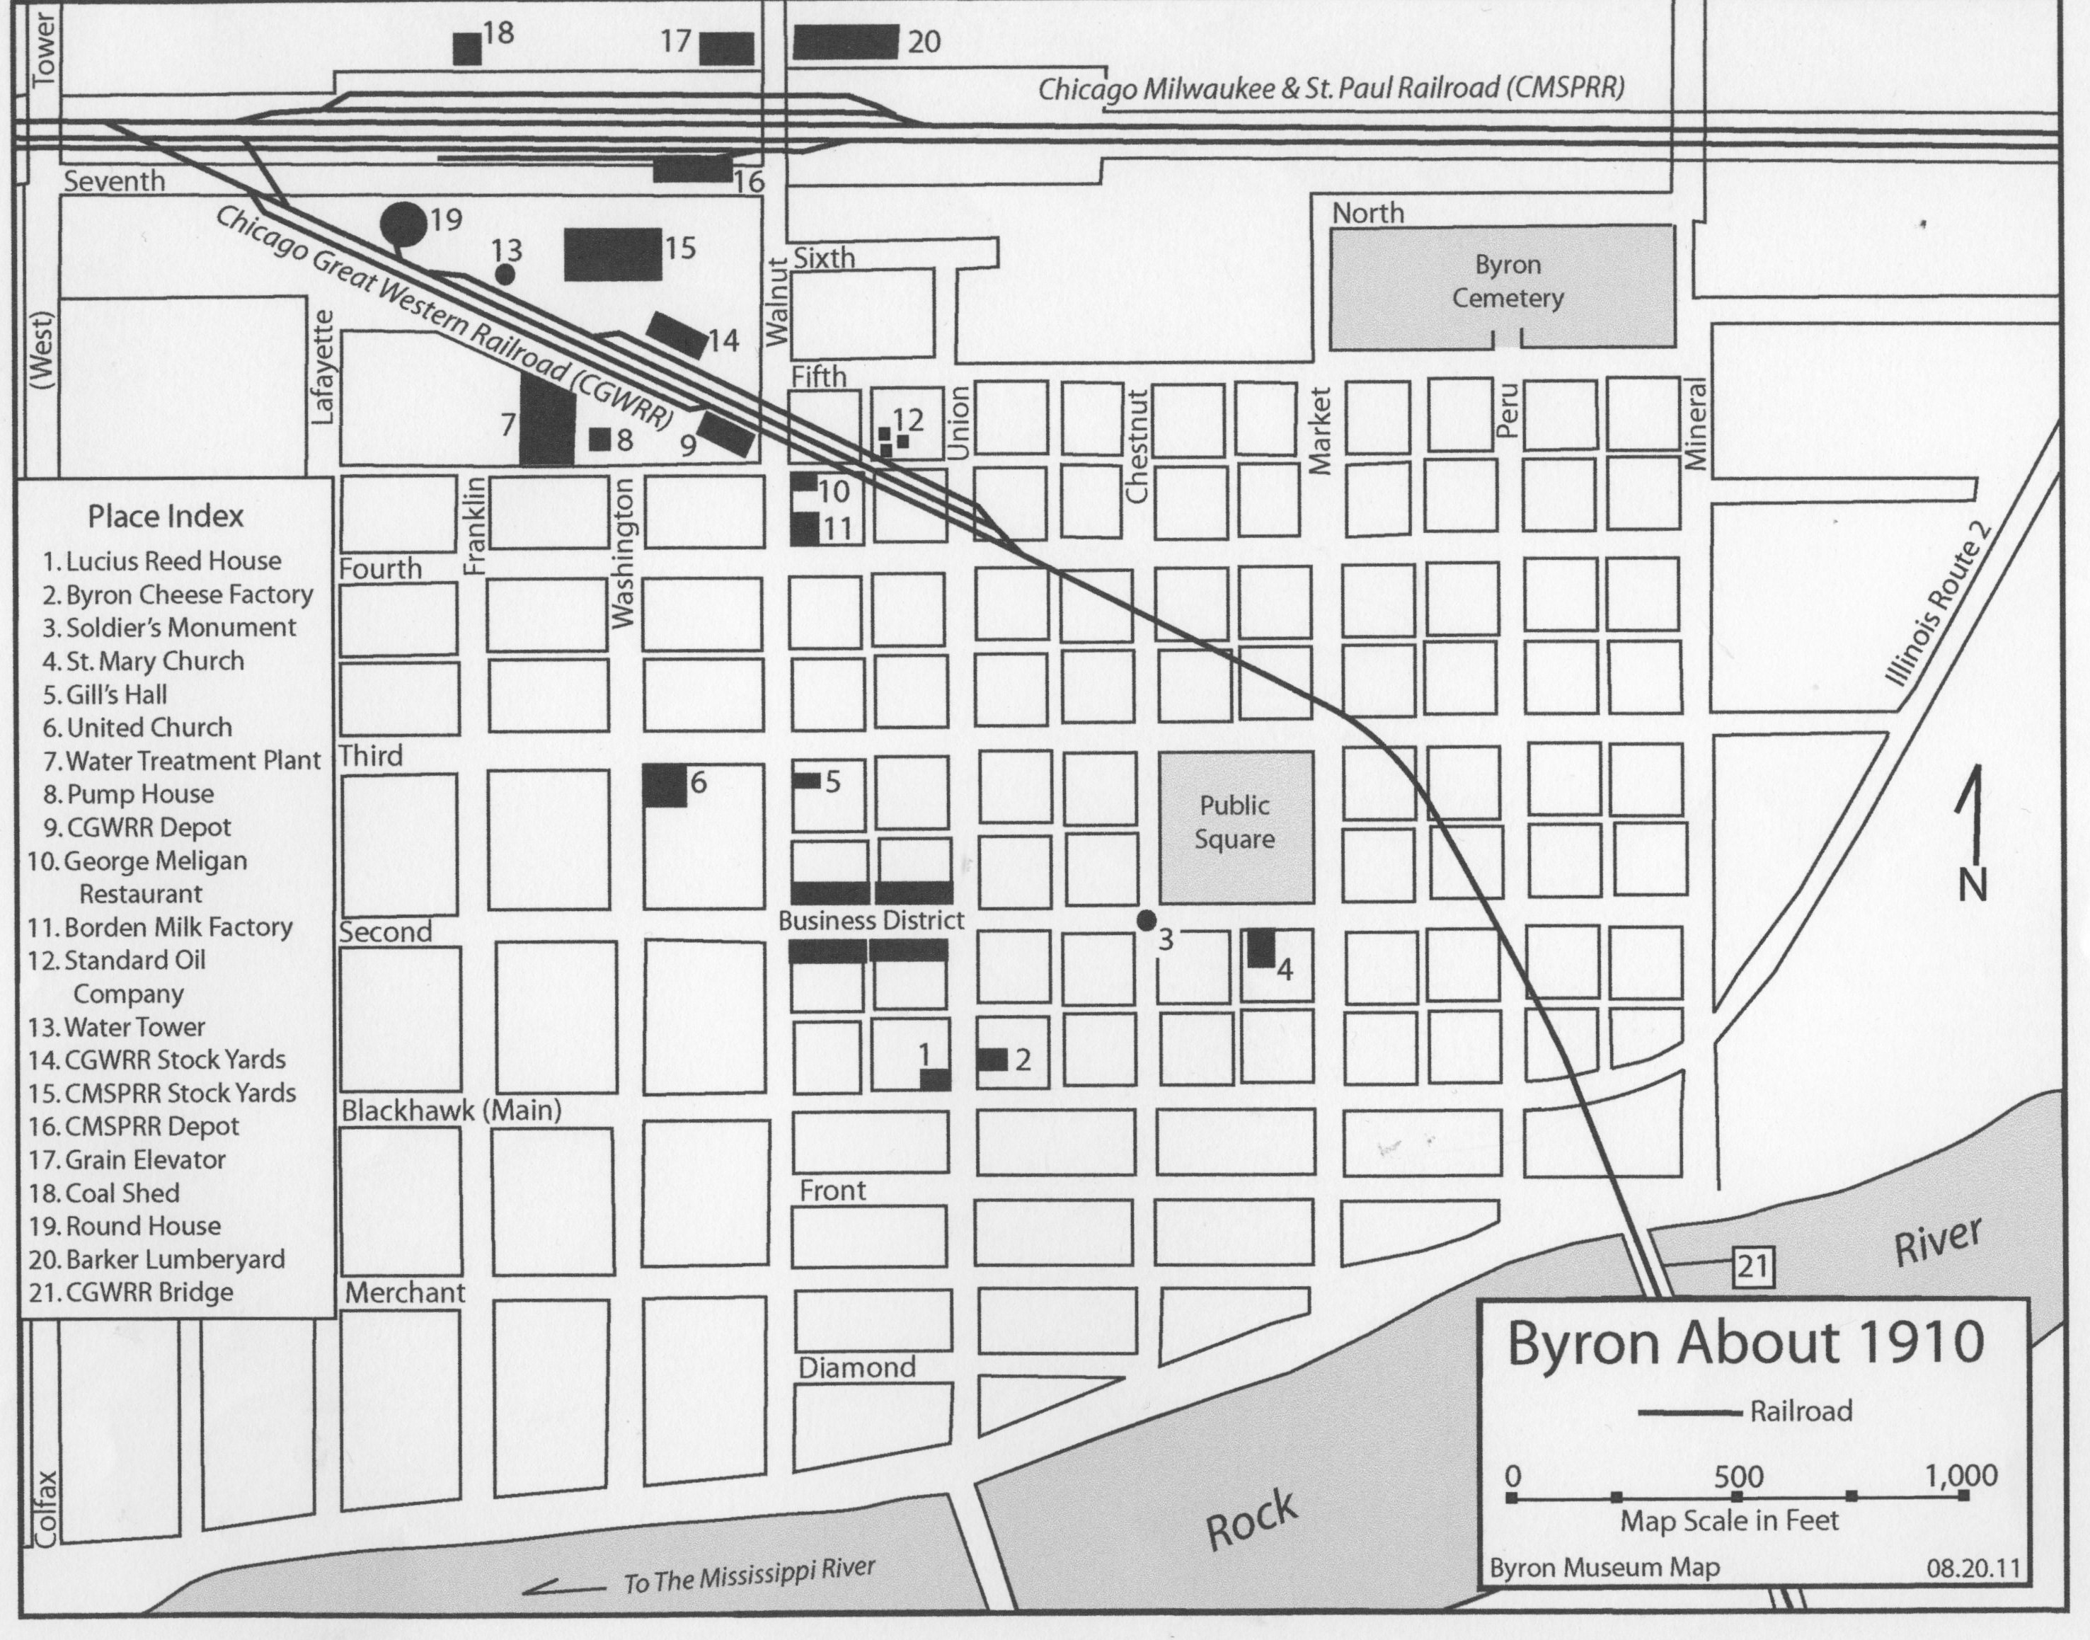

Byron Railroad Map Questions

- This map shows Byron, Illinois in which year?

- Name two streets that are parallel to Blackhawk Street.

- Name two streets that are perpendicular to Third Street.

- Circle which Place is the furthest north:
a. Byron Cheese Factory b. Round House

- Which two directions does the Chicago Milwaukee & St. Paul Railroad run?

- Name three places that are South of the Public Square.

- Name the river that runs near Byron.

- Is the Byron Cemetery East or West of the Coal Shed?

- Which river does the Rock River flow to?
- What are the names of the two railroads that are shown on the map?

- What is the distance between:
a) The Public Square and the Business District?
b) The Round House and the Byron Cemetery?

- What places can you find between Second and Third Street?

- What business is closest to the Standard Oil Company?

- Which place is closer to the Byron Cheese Factory: Gill’s Hall or United Church?

